ATILIM UNIVERSITY

SE112

2023-2024 SPRING SEMESTER

PROJECT PROPOSAL AND MANAGEMENT ASSIGNMENT

Team Information:

Project Group Number: 29

Team Members:

Emre Güneri - 22243610025

Utku Yiğit Ilgar – 22244710032

Sezen Coşkun – 22244710062

Project Title:

My Calorie Buddy

Instructor:

Dr. Ali Yazıcı

Submission Date:

07 March 2024

Project/Problem Description:

The aim of the project is to help users track their daily calorie intake and what they eat in a day while also giving personalized recommendations for achieving their ideal weight by using machine learning algorithms. A mobile app will be developed to enable users to track their meals, snacks, and what they drink with their calorie counts and what time they consumed them. MyCalorieBuddy has a user-friendly design that is accessible to anyone seeking to manage and track their eating habits. Through this app, users can easily monitor their daily calorie intake, track their progress towards goals about their ideal body and weight, and receive personalized recommendations based on their previous inputs about what they eat. The recommendations will be what they should eat , what time they should eat, while giving recipes that are delicious and healthy. By making use of machine learning algorithms, the application will analyze user data, including eating preferences, nutritional requirements, and weight management goals, to generate personalized meal recommendations. The application will follow a fast development method to ensure improvements and timely delivery of features.

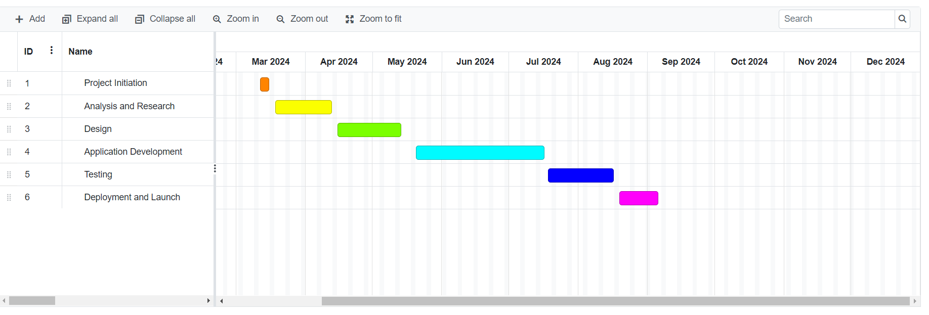

Risk Plan:

|  |  |
| --- | --- |
| Risk 1: The data given by the users may be wrong therefore, the machine learning algorithm can give wrong recommendations and cause health risks and this may lead on to possible law suits. | B plan: Ask the user to double check before inputting the data and then tell the user that the reccomendations given by the app is based on machine learning and anything that come off as unhealty should be advised to a proffesional before consuming. |
| Risk 2: The funder may cancel at the last minute, leaving mycaloriebuddy unfunded, which may delay the developing process by a lot and this could damage the company's reputation. | B plan: Have a diverse group of potential funders and have a contingency plan for any last minute cancellations. |